EXPT NO: 8 Association Rule Learning (Apriori Algorithm) Date: 08.04.26 and Dimensionality Reduction (PCA)

SCENARIO 1: ASSOCIATION RULE MINING USING APRIORI ALGORITHM
Bar chart of frequent itemsets:
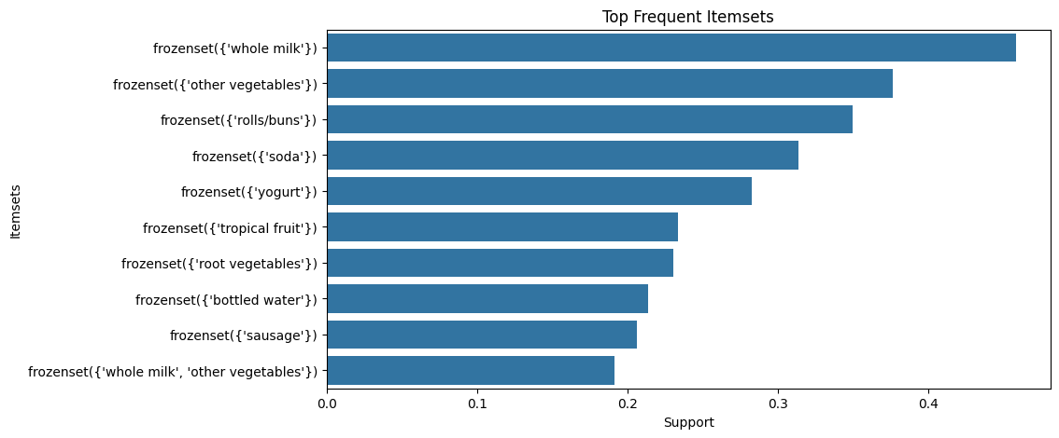
Support vs confidence plots
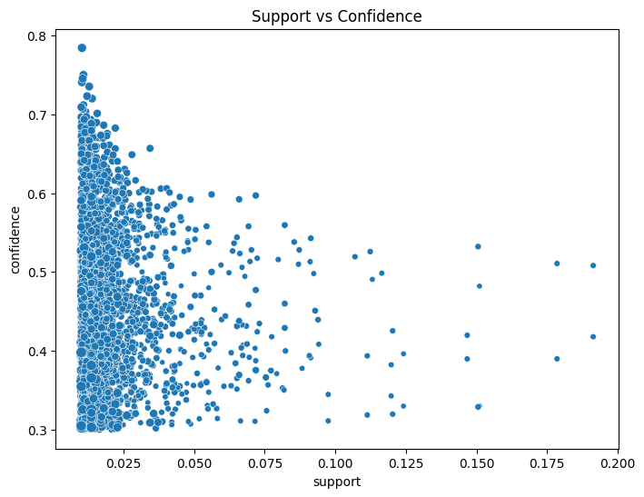
Network graph of association rules:
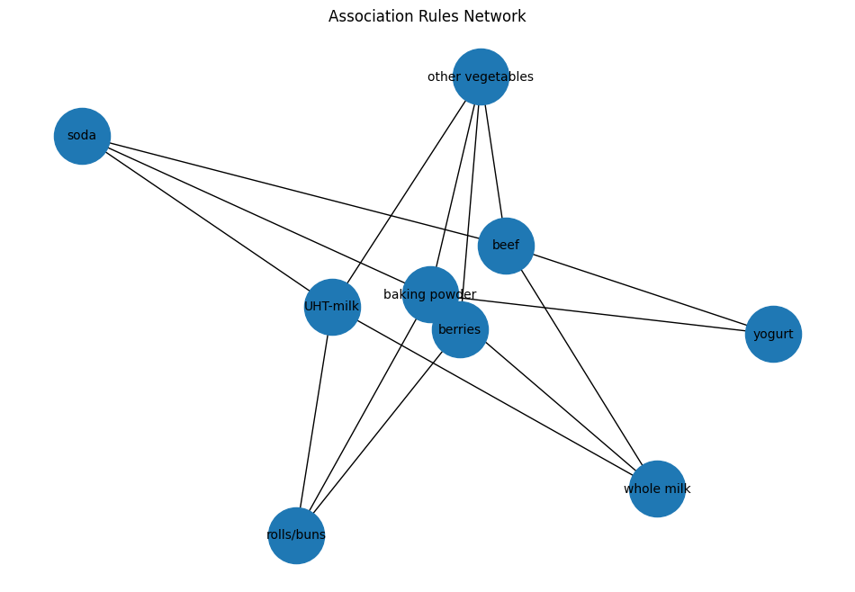
SCENARIO 2 – DIMENSIONALITY REDUCTION USING PCA
Scree plot (variance vs components)
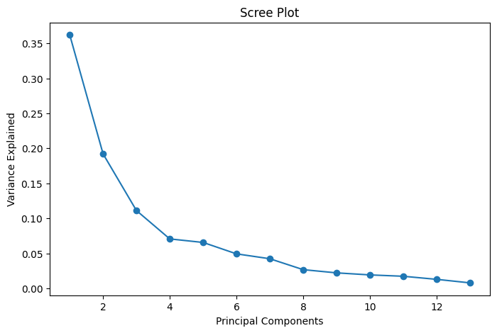
Cumulative variance graph
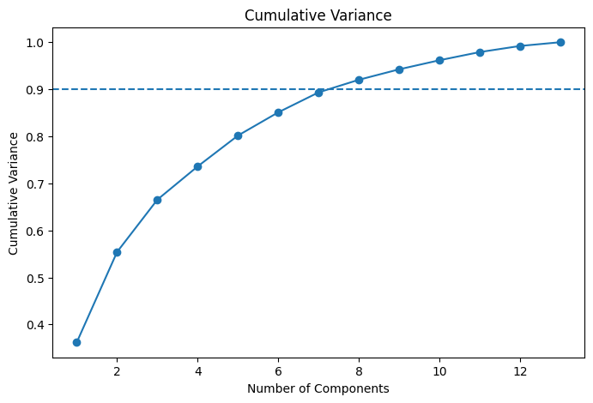
2D scatter plot of principal components
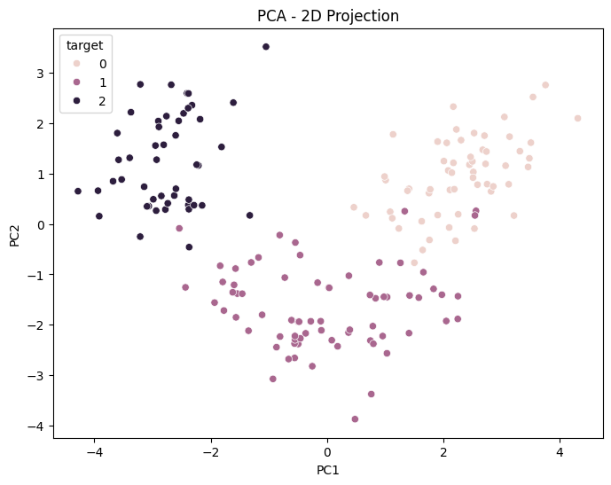
3D scatter plot of principal components
